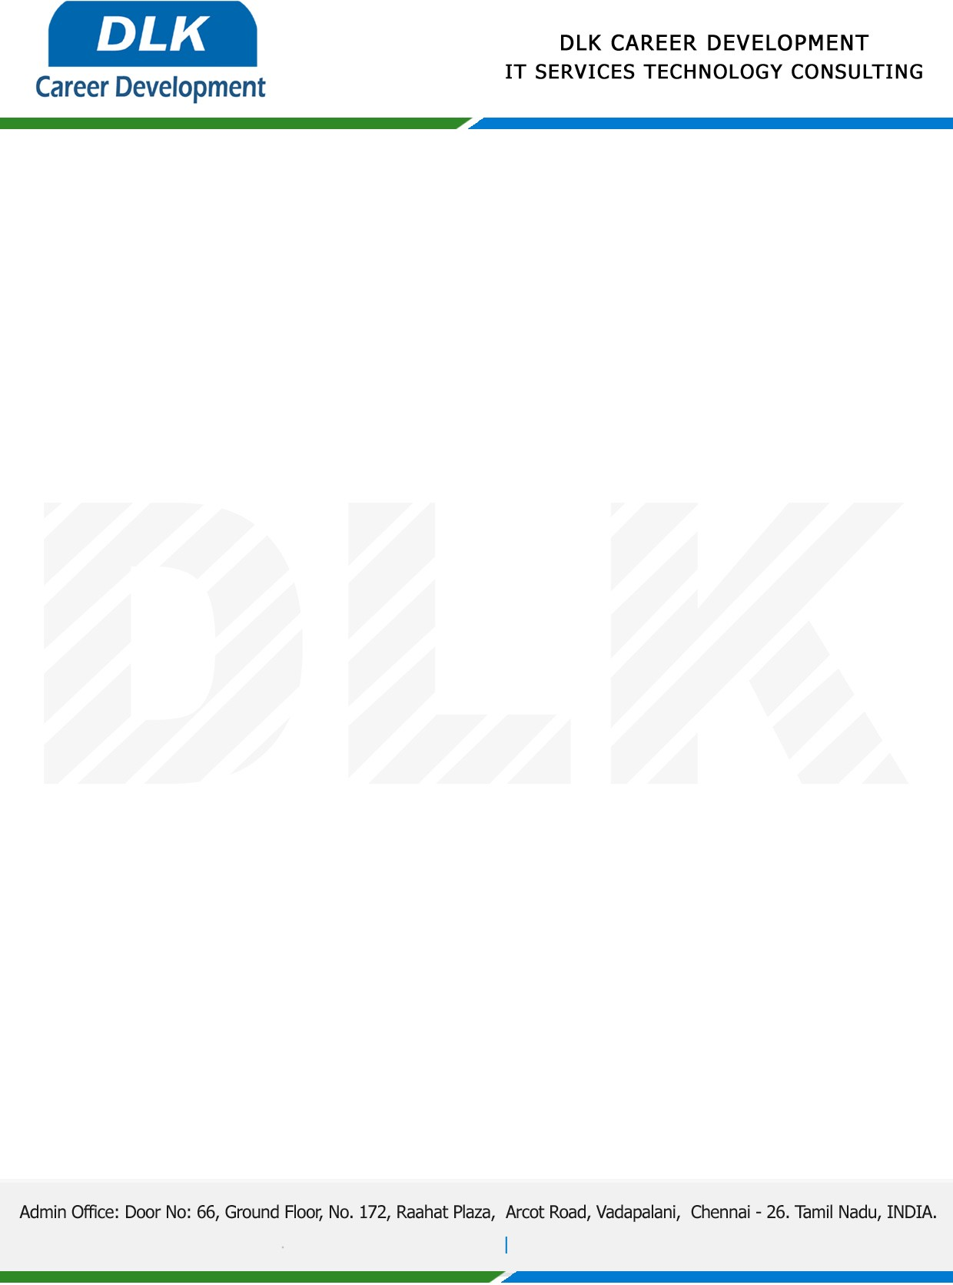

Date: 18/April/ 2023

**SUB: PROJECT COMPLETION CERTIFICATE**

This is to certify that **MR** **SAI SANKAR K (REG NO: 204011101265)** of **BCA (COMPUTER APPLICATION)** final year student at **Dr. M.G.R. Educational And Research Institute, Chennai** has Successfully Completed the Project Work under the title of “**Real Time Implementation of Laundry System “**in our organization during the Period (**January 2023** to **April 2023).**

We appreciate your interest in **DLK CAREER DEVELOPMENT**

For DLK CAREER DEVELOPMENT

**“Best Wishes for Your Future Endeavors “**

